**Lesson 9 – Review**

Personal information

|  |  |
| --- | --- |
| **Names**  What is your name? My name is _______.  What is your surname / last name? My surname / last name is _______.  Do you have a nickname? Yes, my nickname is _______ *or* No, I don't. | **Work & Occupation**  What do you do? I am a _______.  Where do you work? I work at _______.  Do you like your job? Yes, I do. *or* No, I don't.  Why do you like your job? I like my job because _______. |
| **Marital Status**  Are you married / single? Yes, I am. *or* No I'm not.  Do you have a boyfriend / girlfriend? Yes, I do. *or* No, I don't.  What is your partner's name? My partner's name is _______. | **Family**  Do you have any children? Yes, I have _______ children. *or*No, I don't  What are their names? Their names are _______.  How many brothers and sister do you have? I have _______ brothers and _______ sisters. |
| **Age**  How old are you? I am _______ years old.  When is your birthday? My birthday is on the _______ of _______.  Where were you born? I was born in _______. | **Contact Information**  Where are you from? I am from _______.  What is your address? My address is _______.  What is your phone number? My phone number is _______.  What is your cell phone number? My cell phone number is _______.  Do you live with your parents? Yes, I do. *or* No, I don't.  Do you live alone? Yes, I do. *or* No, I don't.  Who do you live with? I live with my _______.  Do you live in a house or an apartment? I live in a/an _______.  What is your e-mail address? My e-mail address is _______. |
| **Free time activities**  What do you do in your free time? In my free time I _______.  What are your hobbies? My hobbies are _______.  What type of music do you like? I like _______ music.  Do you have a favourite singer or group? My favourite singer / group is _______.  What types of movies do you like? I like _______ movies.  Do you like to read? Yes, I do. *or* No, I don't.  What do you like to read? I like to read _______. | Habits Do you have any bad habits? Yes, one of my bad habits is _______.  Do you snore? Yes, I do. *or* No, I don't.  Do you smoke? Yes, I do. *or* No, I don't.  How many cigarettes do you smoke a day? I smoke _______ cigarettes a day. |
| Other Personal Information What is your favourite food? My favourite food is _______.  Is there any food that you do not like? Yes, I don't like _______. *or* I like all food.  What is your favourite colour? My favourite colour is _______.  Why do you want to learn English? I want to learn English because _______.  What languages do you speak? I speak _______.  Do you have any pets? Yes, I do. *or* No, I don't.  What pets do you have? I have _______.  What are their names? Their names are _______. | Which sports do you like? The sport I like is _______.  Do you have a favourite team? My favourite team is _______.  What is something you do well? I am good at _______.  What is something you do not do well? I am bad at _______.  Are you romantic? _______ romantic.  Do you have any tattoos? Yes, I do. *or* No, I don't.  Describe yourself using only two words. I am _______ and _______.  What makes you happy? I am happy when _______.  Are you a good cook/singer/driver? Yes, I do. *or* No, I don't. |

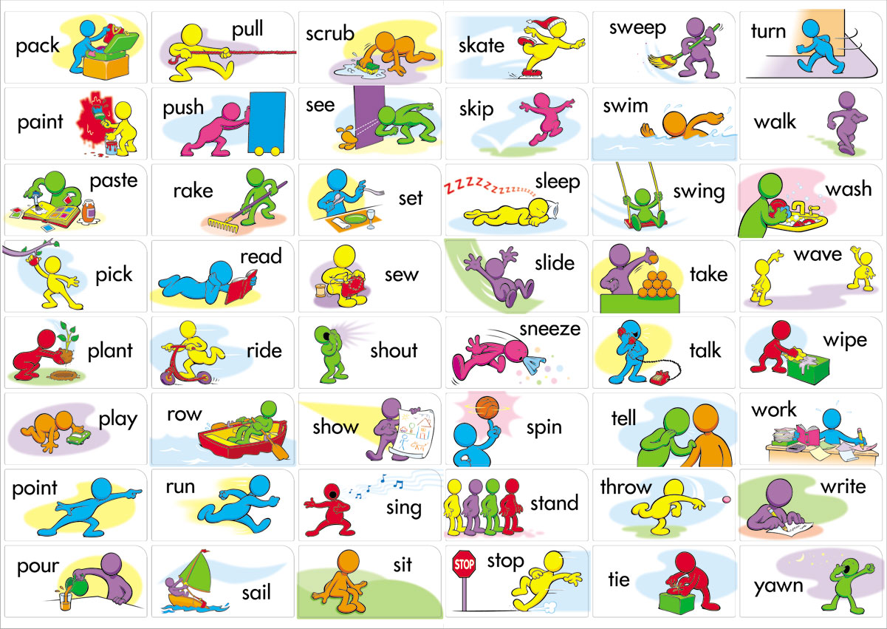

|  |  |  |  |  |  |
| --- | --- | --- | --- | --- | --- |
| pack /pæk/ | pull /pʊl/ | scrub /skrʌb/ | skate /skeɪt/ | sweep /swiːp/ | turn /tɜːn/ |
| paint /peɪnt/ | push /pʊʃ/ | see /siː/ | skip /skɪp/ | swim /swɪm/ | walk /wɔːk/ |
| paste /peɪst/ | rake /reɪk/ | set /set/ | sleep /sliːp/ | swing /swɪŋ/ | wash /wɒʃ/ |
| pick /pɪk/ | read /riːd/ | sew /səʊ/ | slide /laɪd/ | take /teɪk/ | wave /weɪv/ |
| plant /plɑːnt/ | ride /raɪd/ | shout /ʃaʊt/ | sneeze /sniːz/ | talk /tɔːk/ | wipe /waɪp/ |
| play /pleɪ/ | row /rəʊ/ | show /ʃəʊ/ | spin /spɪn/ | tell /tel/ | work /wɜːk/ |
| point /pɔɪnt/ | run /rʌn/ | sing /sɪŋ/ | stand /stænd/ | throw /θrəʊ/ | write /raɪt/ |
| pour /pɔːr/ | sail /seɪl/ | sit /sɪt/ | stop /stɒp/ | tie /taɪ/ | yawn /jɔːn/ |